Title in Arial (13 pt Bold) Using First Capital Letters

Presenting Author ª*, Second Author ^{b}, and Principal Investigator^{a,b}

ª Institution, Full institutional address.
^{b} Institution, Full institutional address.
E-mail: email address of presenting author

Main Text Guidelines
The total length of the proceeding must not exceed One page. Please type directly into this template to maintain a consistent format across all submissions. Use the Text Style: Arial 11 pt, justified for the main text.

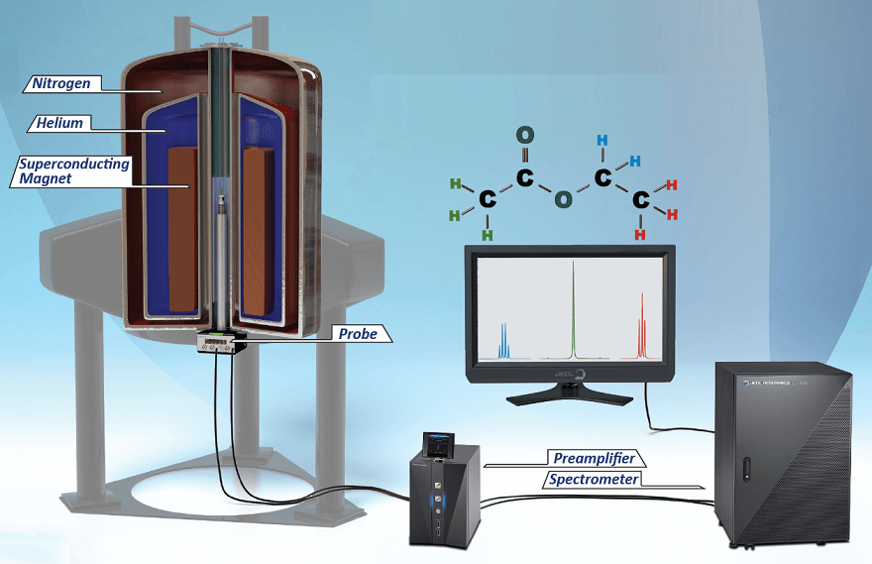

Figure 1. Caption (Arial 11pt)

References
[1] M.J. Thompson, K.R. Patel, L. Chen, Recent developments in fluorescence-based metal ion sensing, Anal. Chim. Acta 1267 (2023) 45–62.
[2] D.A. Skoog, F.J. Holler, S.R. Crouch, Principles of Instrumental Analysis, seventh ed., Cengage Learning, Boston, 2018.
[3] E. Nakamura, J.P. Ruiz, Advances in electrochemical detection for biosensor applications, in: T.S. Miller, A. Robinson (Eds.), Modern Techniques in Bioanalytical Chemistry, Springer, Berlin, 2021, pp. 233–259.

